**Activity 5: Blog Platform API + UI**

The Blog Platform API is a web application designed to allow users to create, share, and connect through blog posts. It provides a platform where individuals can express their thoughts, ideas, and stories in a simple and interactive way.

**Members:**

Andaya, Rhodel

Benito, Patrick Raymond P.

Cielo, Ivan Louis D.

De Leon, Justin Carl V.

Dela Cruz, Althea

Dela Cruz, Filbert B.

**Steps in showing functionality:**

**Home Page Interface**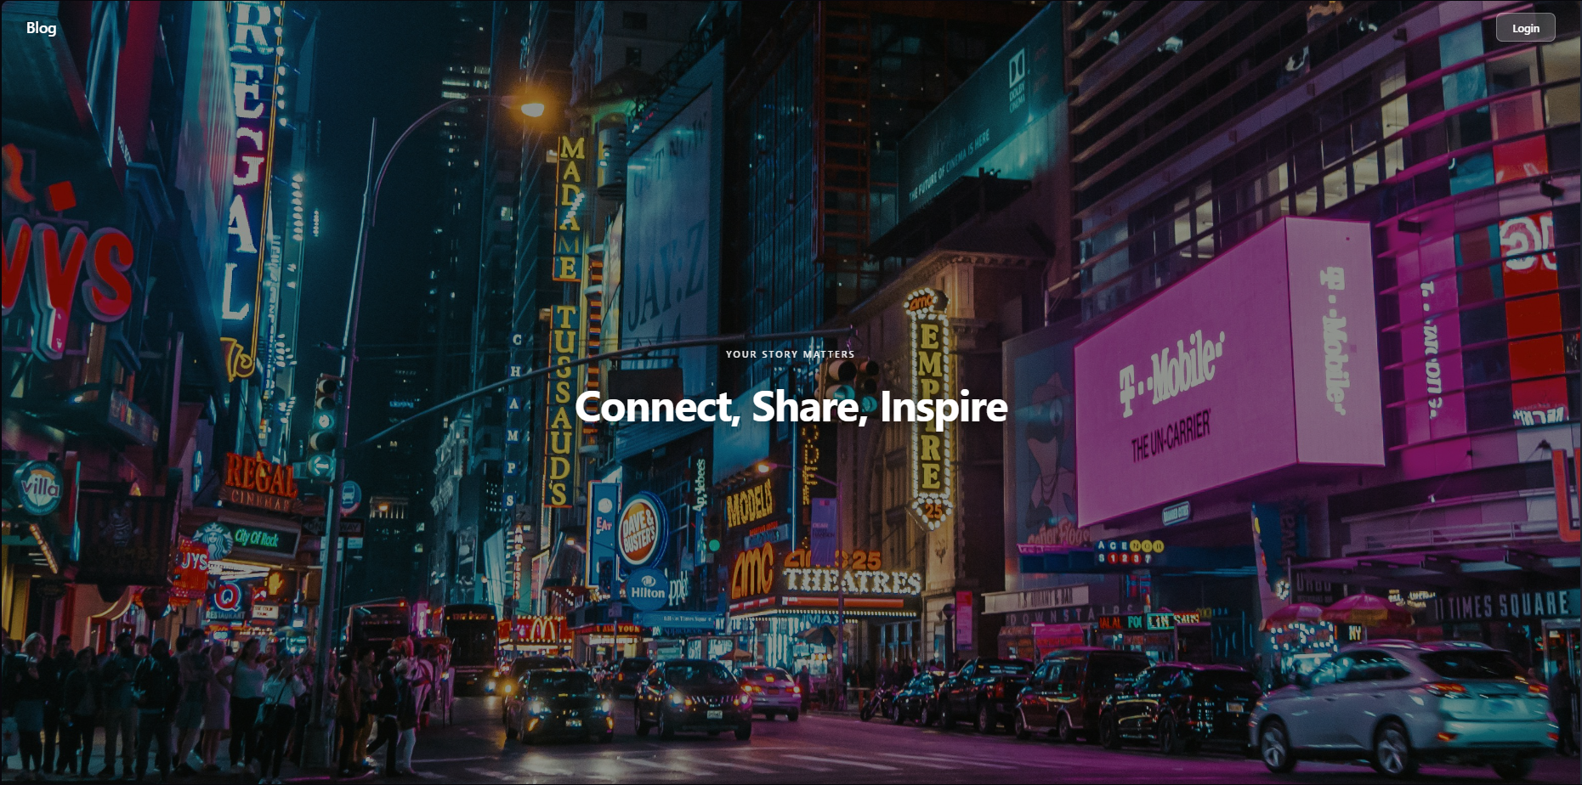

Upon opening the **Blog Platform API**, the user is greeted with a clean and welcoming **homepage** that highlights the platform’s purpose.

At the top, the **“Blog”** label functions as a **logo**, representing the identity of the platform. It is accompanied by a **Login** button in where you can register and login an account.

**Sign-Up Functionality**

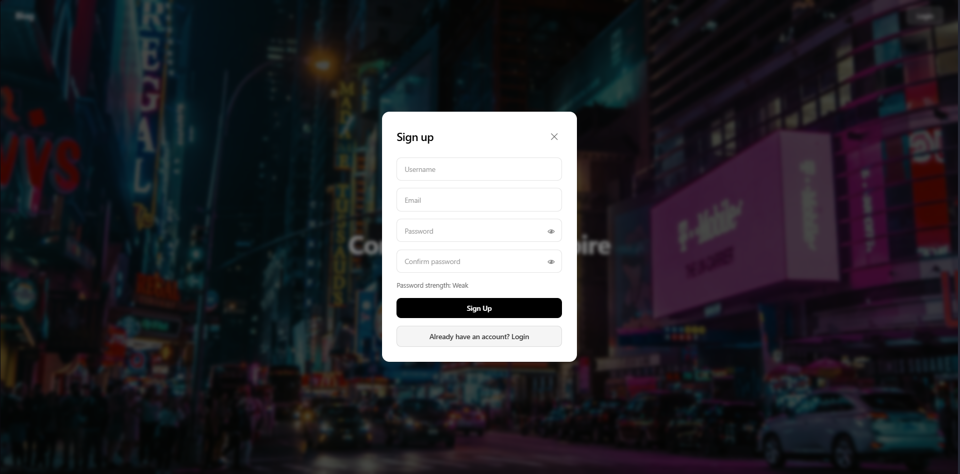

This allows new users to create an account and join the Blog Platform community. It features a clean, centered form layout over a blurred cityscape background, giving it a modern and focused appearance.

**This page includes the following input fields:**

* **Username** –used to uniquely identify the user within the platform.
* **Email** –for account verification and login credentials.
* **Password** – the user’s chosen secure password.
* **Confirm Password** – ensures that the entered password matches correctly.

A **password strength indicator** is displayed below the input fields to help users create stronger passwords for better account security.

Once all fields are filled, clicking the **Sign Up** button creates a new user account and you can now use that to Login.

At the bottom, there’s also a **“Already have an account? Login”** link, allowing existing users to quickly switch to the login form.

**Login Functionality**

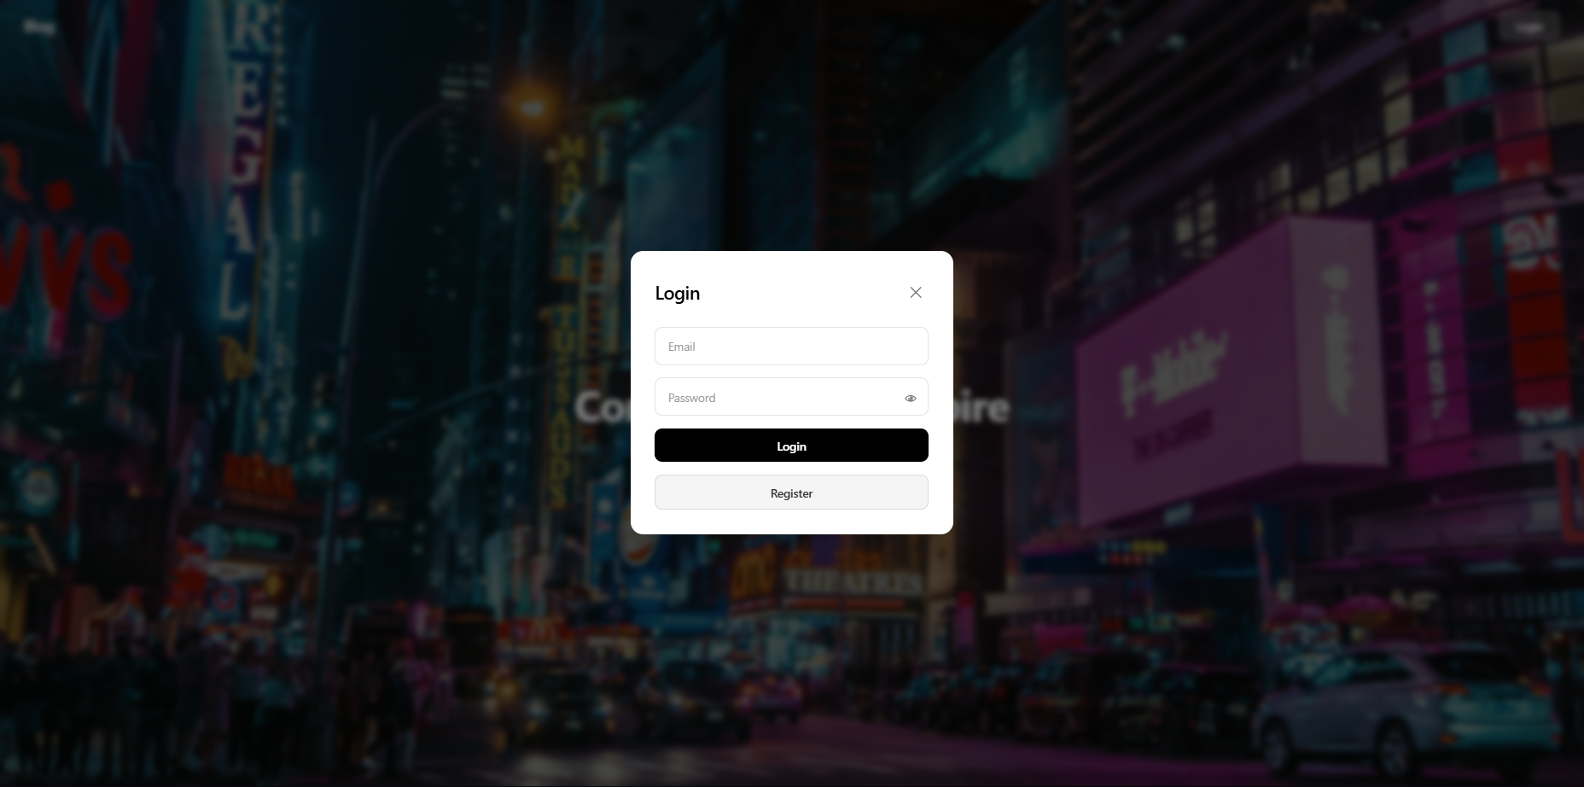

This allows registered users to securely access their accounts within the Blog Platform. It maintains the same aesthetic design as the sign-up page, featuring a **blurred city background** and a clean, centered login form that enhances focus and readability.

This page includes the following input fields:

* **Email** – used as the primary login credential.
* **Password** – the corresponding secure password for account access.

Below the input fields, a **Login button** is provided to authenticate the user’s credentials and can now use the main blog interface upon successful verification.

Additionally, a **“Register”** link is available at the bottom of the form, allowing new users to easily navigate to the sign-up page if they don’t have an account yet.

**Create Post Functionality**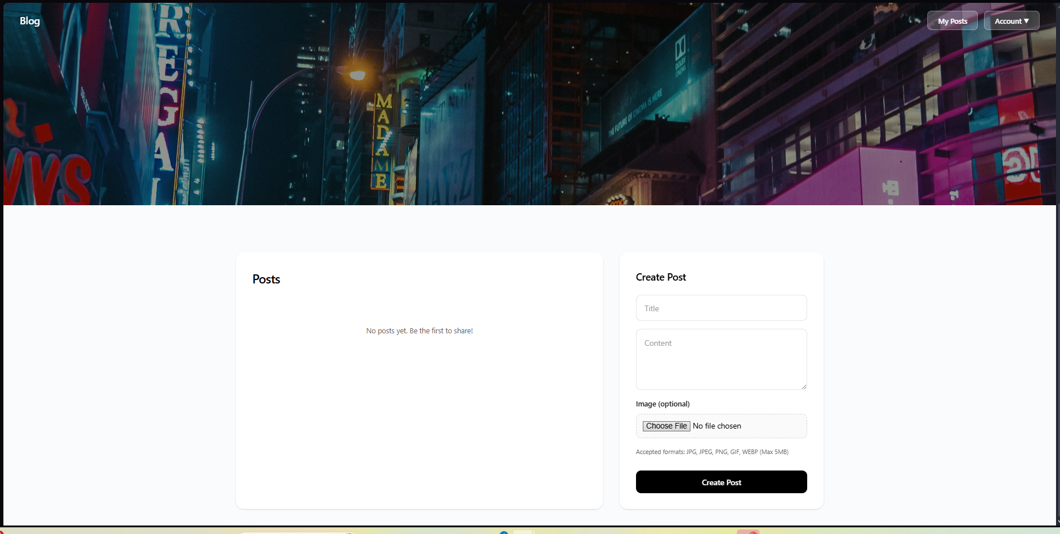

After successfully logging in, users are redirected to the main dashboard where they can **create and share blog posts**. The interface is divided into two primary sections, the **Posts display panel** on the left and the **Create Post form** on the right.

The **Create Post** form allows users to compose and publish new content easily with the following fields and options:

* **Title** – the main heading or topic of the blog post.
* **Content** – a text area for writing the body of the post.
* **Image (optional)** – lets users upload an image related to their post. Accepted formats include JPG, JPEG, PNG, GIF, and WEBP (maximum size: 5MB).
* **Create Post button** – submits the post to the platform once completed.

The top-right navigation bar also updates to include **“My Posts”** and an **“Account” dropdown menu** for managing the user profile or logging out.

**My Posts – Post Preview Modal**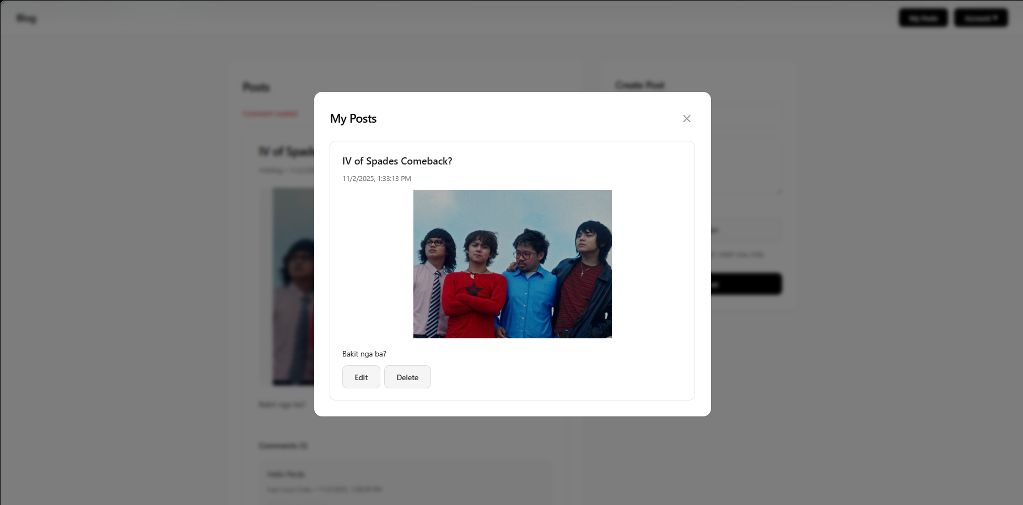

When users click **“My Posts”** from the navigation bar, a modal window appears showing all the posts they have created.

Then you can now edit a specific post just by scrolling up and down inside the **Post Preview Modal**, where the selected post’s full content is displayed in a focused, centered layout for easy review.

This modal includes the following key elements:

* **Post Title** – displayed at the top of the modal.
* **Date and Time** – shows when the post was created or published.
* **Post Image** – displays the uploaded image related to the post (if available).
* **Post Content** – the written body or caption provided by the user.
* **Edit Button** – allows the user to modify the post’s title, content, or image.
* **Delete Button** – permanently removes the post from the user’s list.

**View Profile Functionality:**

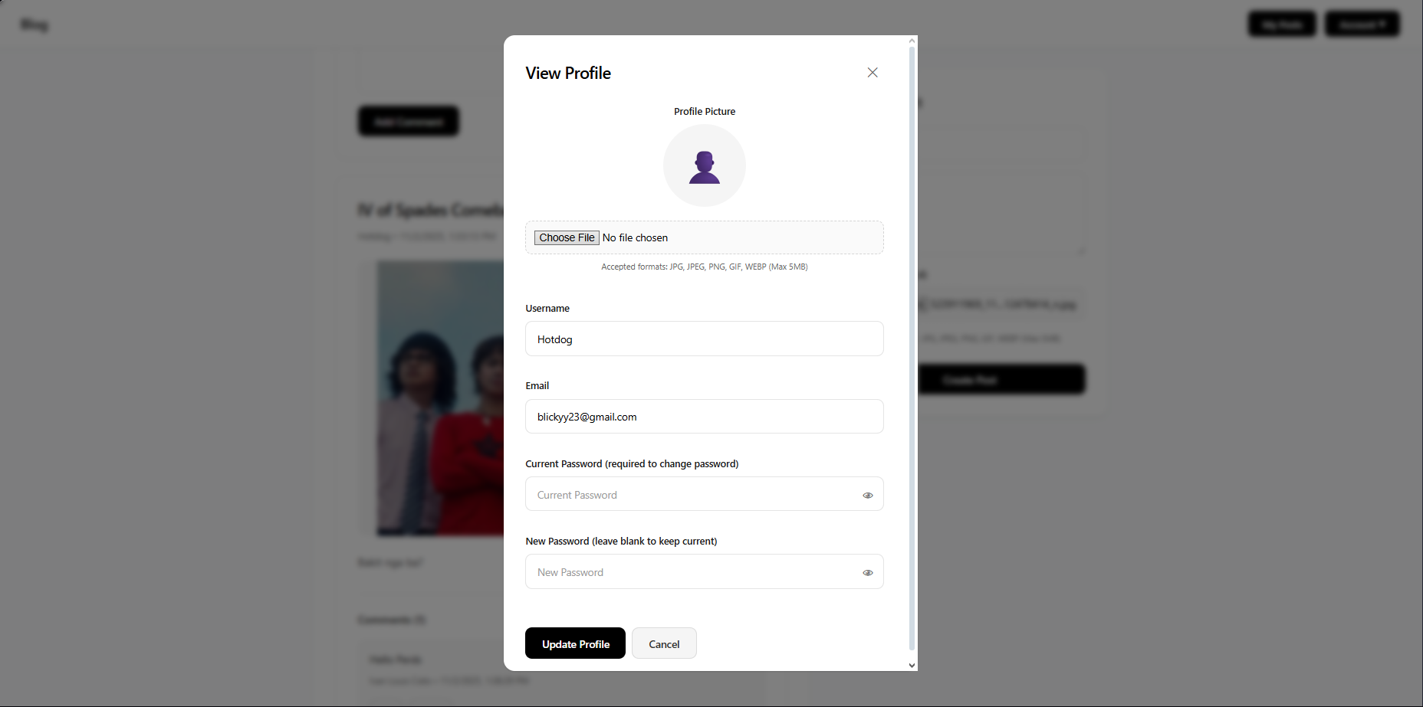

When users click **“View Profile”** from the **Account Dropdown**, a centered modal window appears showing their current account details and settings.

This **View Profile modal** allows users to conveniently review and update their personal information without leaving the page.

The modal contains the following elements:

* **Profile Picture** – displays the current profile image or a default avatar.
* **Username Field** – shows the user’s current username, which can be edited.
* **Email Field** – displays the registered email address for identification or updates.
* **Password Section** –  
  + **Current Password** – required if the user intends to change their password.
  + **New Password** – optional; leave blank to retain the current password.
  + Eye icons toggle password visibility for secure editing.
* **Update Profile Button** – saves all modifications made to the profile.
* **Cancel Button** – closes the modal without applying changes.

**API Connectivity Testing:**

**User Registration**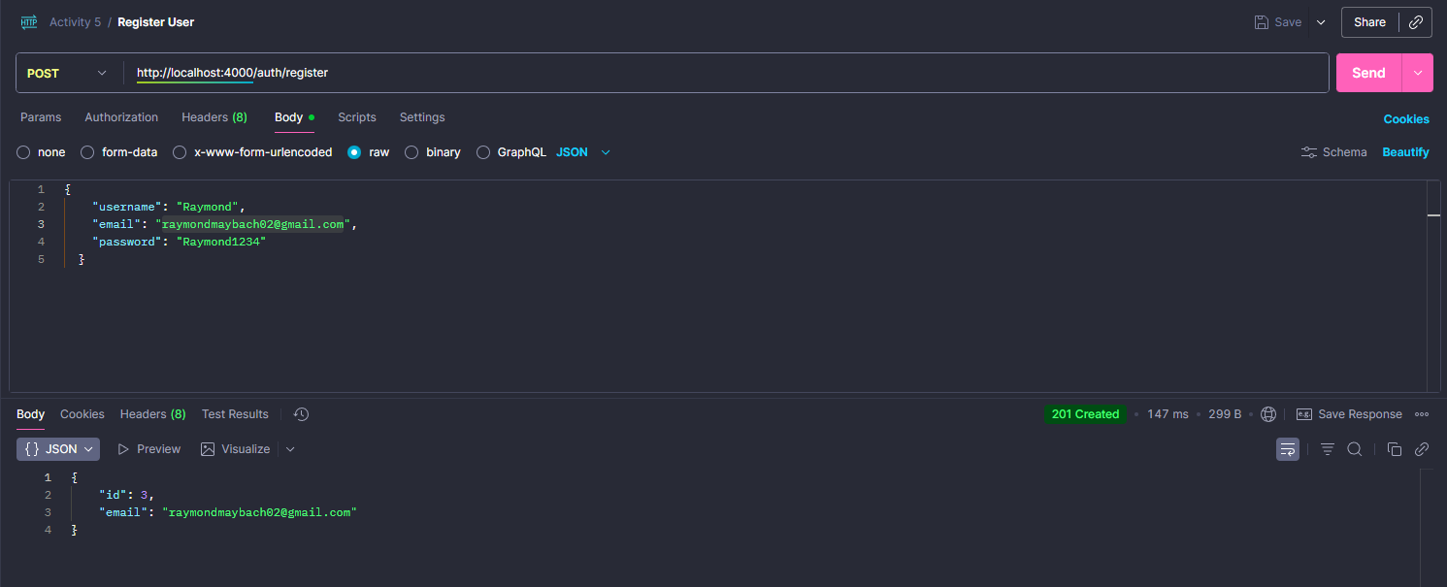

This test validates the user registration functionality through a POST request to the /auth/register endpoint, demonstrating the API's ability to create new user accounts in the authentication system.

**Endpoint Details:**

* **Method:** POST
* **URL:** http://localhost:4000/auth/register
* **Content-Type:** application/json (raw JSON)
* **Response Status:** 201 Created
* **Response Time:** 147ms
* **Payload Size:** 299 B

**User Login**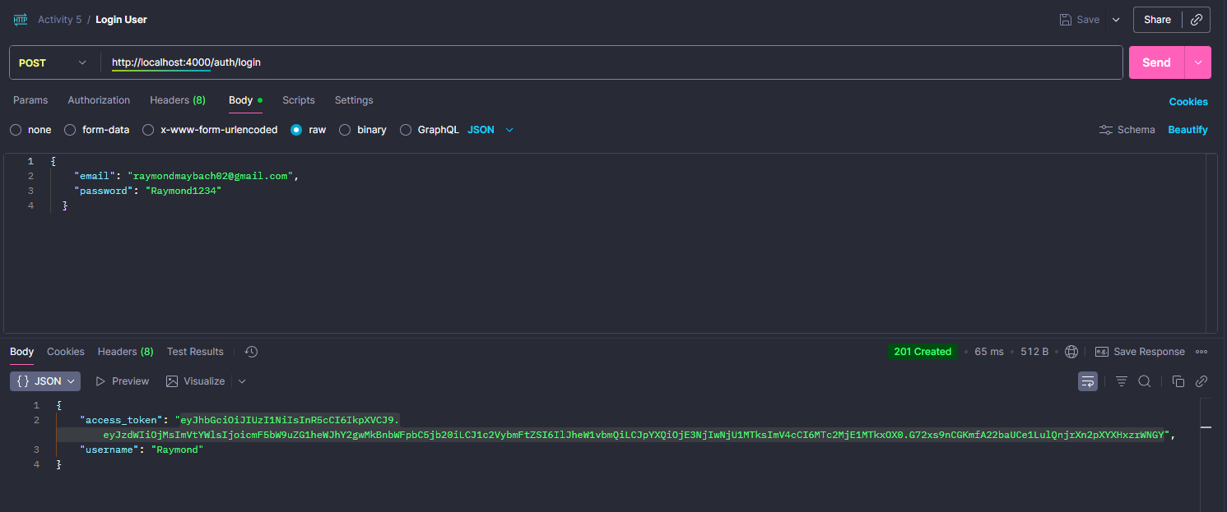

This test validates the user authentication functionality through a POST request to the /auth/login endpoint, demonstrating the API's ability to authenticate existing users and issue access tokens.

**Endpoint Details:**

* **Method:** POST
* **URL:** http://localhost:4000/auth/login
* **Content-Type:** application/json (raw JSON)
* **Response Status:** 201 Created
* **Response Time:** 65ms
* **Payload Size:** 512 B

**Create a Post**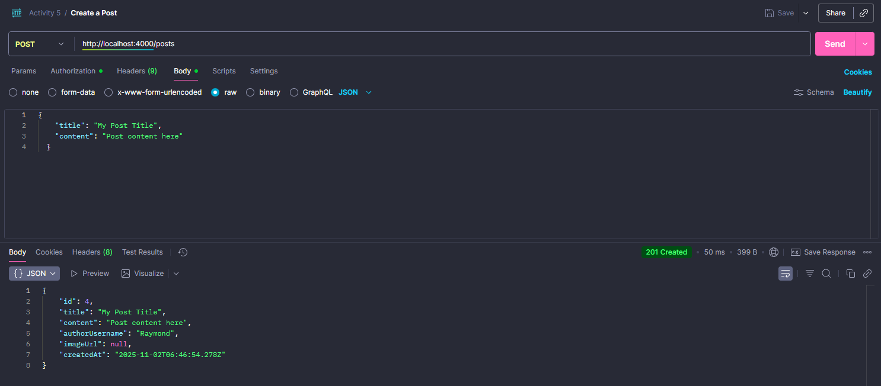

This test validates the post creation functionality through an authenticated POST request to the /posts endpoint, demonstrating the API's ability to create user-generated content with proper authorization.

**Endpoint Details:**

* **Method:** POST
* **URL:** http://localhost:4000/posts
* **Content-Type:** application/json (raw JSON)
* **Authentication:** Bearer Token (Required)
* **Response Status:** 201 Created
* **Response Time:** 50ms
* **Payload Size:** 399 B

**Authentication Requirement:** ⚠️ **This is a protected endpoint** - Authentication is mandatory using a Bearer Token in the Authorization header. Without a valid access token from the login endpoint, requests will be rejected with 401 Unauthorized.

**Get All Posts**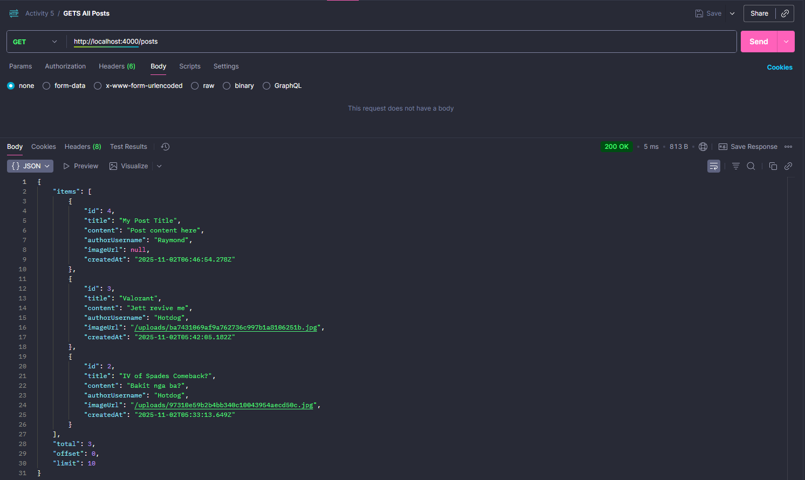

This test validates the retrieval of all posts through a GET request to the /posts endpoint, demonstrating the API's ability to fetch a paginated collection of user-generated posts.

**Endpoint Details:**

* **Method:** GET
* **URL:** http://localhost:4000/posts
* **Authentication:** Not Required (Public endpoint)
* **Response Status:** 200 OK
* **Response Time:** 5ms
* **Payload Size:** 813 B

**Update a Post**

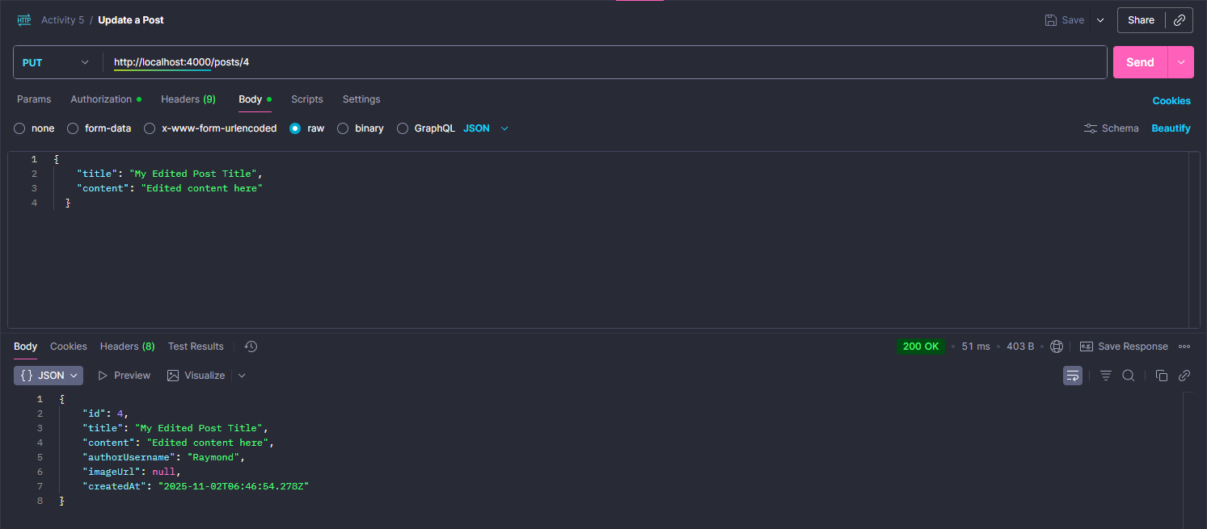

This test validates the post update functionality through an authenticated PUT request to the /posts/{id} endpoint, demonstrating the API's ability to modify existing user-generated content with proper authorization.

**Endpoint Details:**

* **Method:** PUT
* **URL:** http://localhost:4000/posts/4
* **Path Parameter:** id=4 (Target post identifier)
* **Content-Type:** application/json (raw JSON)
* **Authentication:** Bearer Token (Required)
* **Response Status:** 200 OK
* **Response Time:** 51ms
* **Payload Size:** 403 B

**Delete a Post**

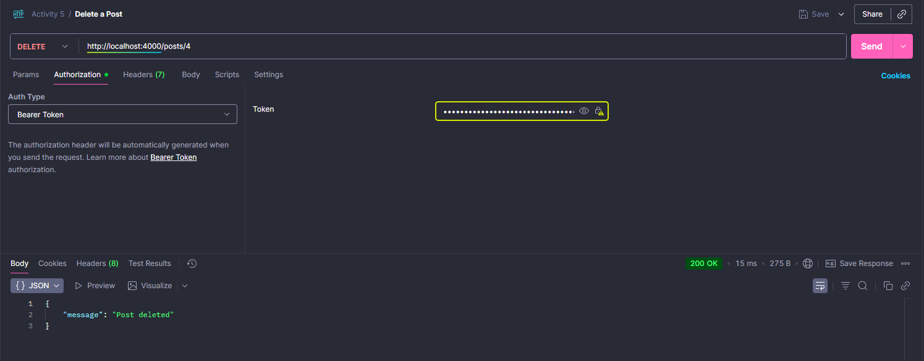

This test validates the post deletion functionality through an authenticated DELETE request to the /posts/{id} endpoint, demonstrating the API's ability to permanently remove user-generated content with proper authorization.

**Endpoint Details:**

* **Method:** DELETE
* **URL:** http://localhost:4000/posts/4
* **Path Parameter:** id=4 (Target post identifier)
* **Authentication:** Bearer Token (Required)
* **Response Status:** 200 OK
* **Response Time:** 15ms
* **Payload Size:** 275 B

**Post a Comment**

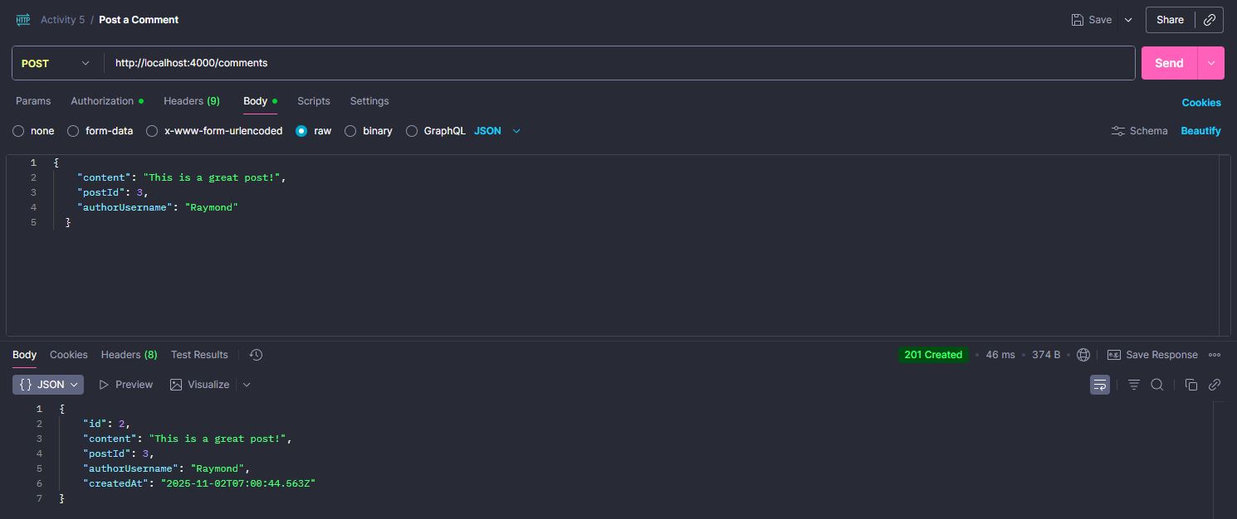

This test validates the comment creation functionality through an authenticated POST request to the /comments endpoint, demonstrating the API's ability to add user comments to existing posts with proper authorization.

**Endpoint Details:**

* **Method:** POST
* **URL:** http://localhost:4000/comments
* **Content-Type:** application/json (raw JSON)
* **Authentication:** Bearer Token (Required)
* **Response Status:** 201 Created
* **Response Time:** 46ms
* **Payload Size:** 374 B

**Get All Comments**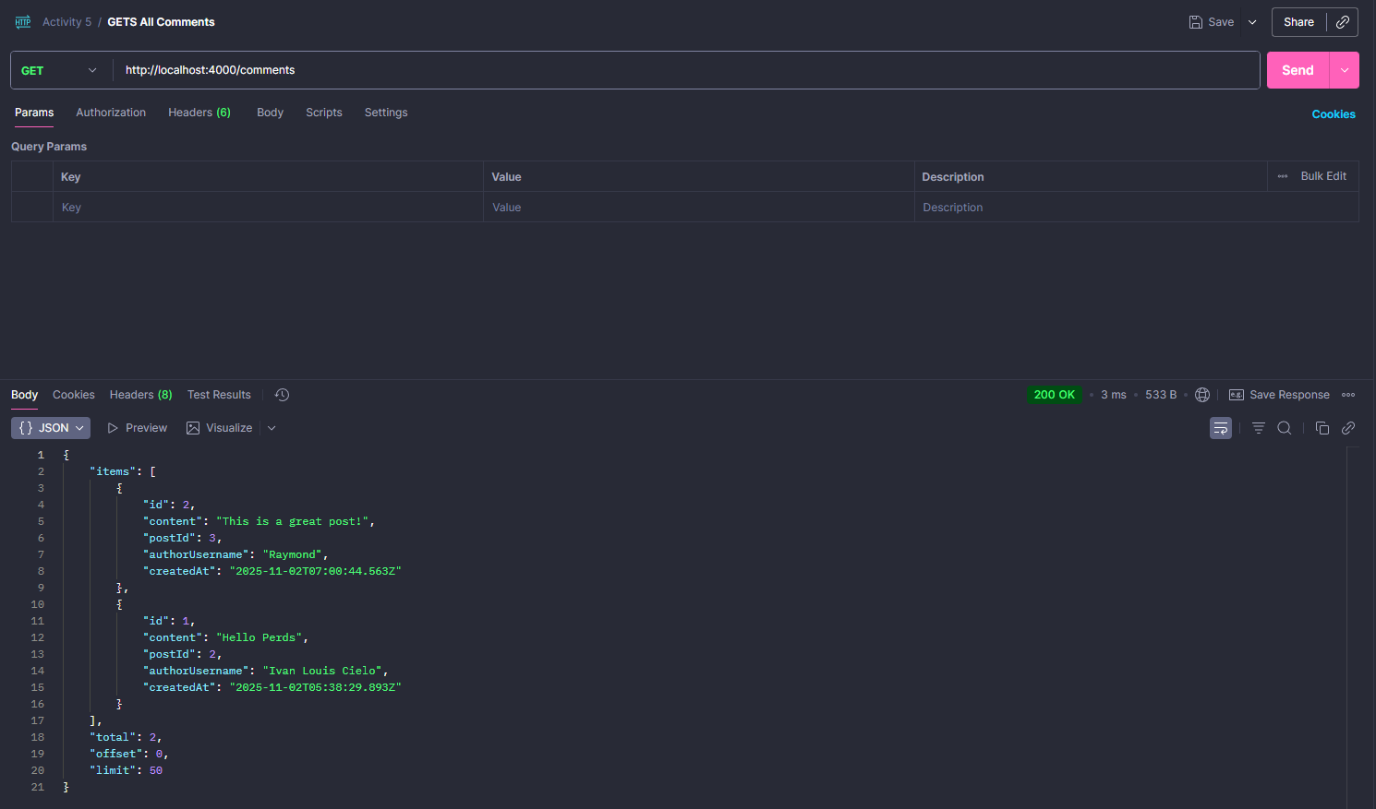

This test validates the retrieval of all comments through a GET request to the /comments endpoint, demonstrating the API's ability to fetch a paginated collection of user comments across all posts.

**Endpoint Details:**

* **Method:** GET
* **URL:** http://localhost:4000/comments
* **Authentication:** Not Required (Public endpoint)
* **Response Status:** 200 OK
* **Response Time:** 3ms
* **Payload Size:** 533 B

**Update a Comment**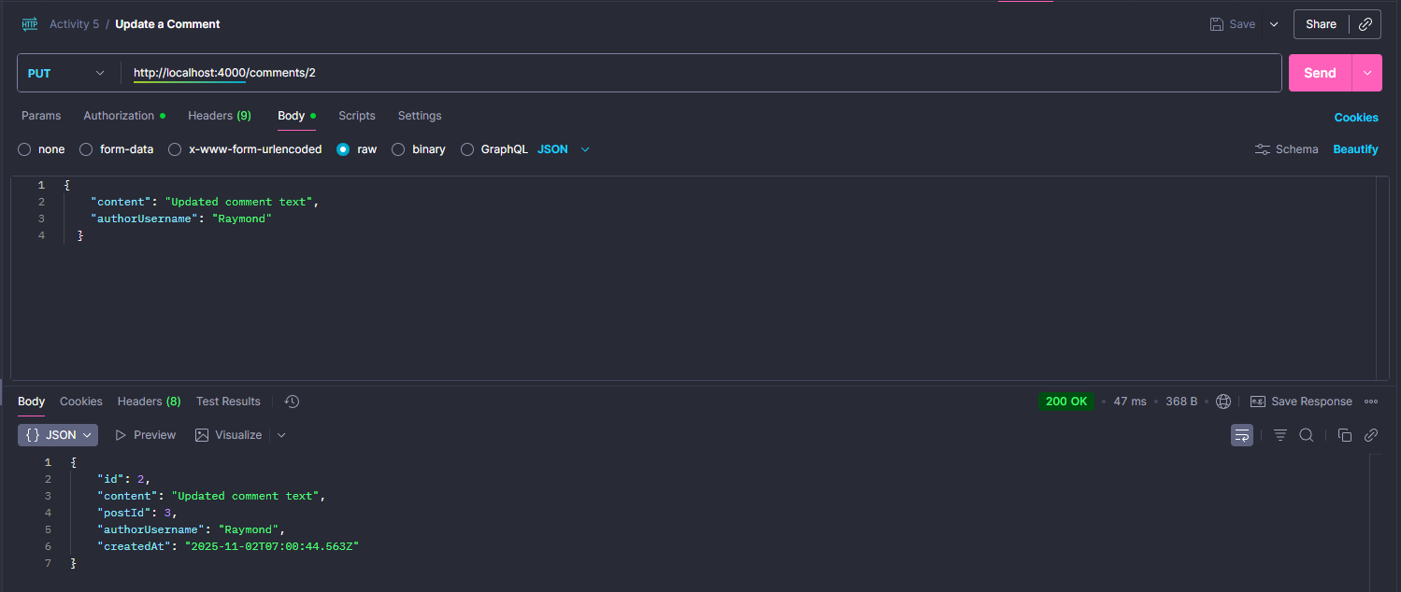

This test validates the comment update functionality through an authenticated PUT request to the /comments/{id} endpoint, demonstrating the API's ability to modify existing comments with proper authorization.

**Endpoint Details:**

* **Method:** PUT
* **URL:** http://localhost:4000/comments/2
* **Path Parameter:** id=2 (Target comment identifier)
* **Content-Type:** application/json (raw JSON)
* **Authentication:** Bearer Token (Required)
* **Response Status:** 200 OK
* **Response Time:** 47ms
* **Payload Size:** 368 B

**Delete a Comment**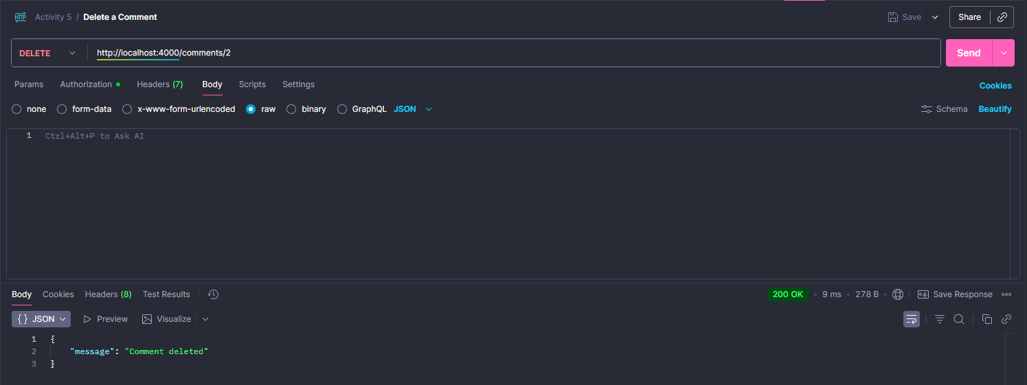

This test validates the comment deletion functionality through an authenticated DELETE request to the /comments/{id} endpoint, demonstrating the API's ability to permanently remove user comments with proper authorization.

**Endpoint Details:**

* **Method:** DELETE
* **URL:** http://localhost:4000/comments/2
* **Path Parameter:** id=2 (Target comment identifier)
* **Authentication:** Bearer Token (Required)
* **Response Status:** 200 OK
* **Response Time:** 9ms
* **Payload Size:** 278 B

# 

# **Project Setup Guide**

Complete documentation for setting up and running the Digital Bookshelf application.

## **Prerequisites**

* Node.js 18+ and npm

## **Installation**

### **Step 1: Clone and Install Dependencies**

git clone <your-repo-url>

cd activity_5

# Backend

cd server

npm install

# Frontend

cd ../client

npm install

**Database**

**Step 1: Create database blog_db in MySQL**

**In Bash:** mysql -u root -p -e "CREATE DATABASE blog_db;"

**Check if it was created:** mysql -u root -p -e "SHOW DATABASES;"

**Step 2:** Upload/Import the .sql file

**In Bash:** mysql -u root -p blog_db < create_database.sql

**Step 3:** Edit the .env with your own DB_PASS

## **Running the Application**

### Step 4: Start Backend

cd server

npm run start:dev

**Backend runs at http://localhost:4000**

### Step 5: Start Frontend

cd client

npm start

**Frontend runs at http://localhost:3001 or http://localhost:3000**

## 

## 

## 

## 

## **Troubleshooting**

**"Request failed" Error on Registration/Login**

**SOLUTIONS:**

**\*\*1. Backend Server Not Running\*\***

**```**

**bash**

cd server

npm run start:dev

```

**Wait for:** `Nest application successfully started`

**\*\*2. Database Connection Failed\*\***

- Check MySQL is running

- Verify `server/.env` file exists with correct credentials:

```env

**DB_HOST**=127.0.0.1

**DB_PORT**=3306

**DB_USER**=root

**DB_PASS**=your_password

**DB_NAME**=blog_db

**JWT_SECRET**=supersecretjwt

**JWT_EXPIRES**=1d

**PORT**=4000

```

- **Create database if missing:**

```bash

mysql -u root -p < create_database.sql

```

**\*\*3. Frontend Not Running\*\***

```

**bash**

cd client

npm start

```

**## Backend Server Won't Start**

**\*\*Database Connection Error\*\***

- Verify MySQL service is running

- Check `.env` file credentials match your MySQL setup

- Test connection: `mysql -u root -p`

**\*\*Missing Dependencies\*\***

```

**bash**

cd server

npm install

```

**## Frontend Won't Start**

**\*\*Port Already in Use (3000)\*\***

- React will automatically suggest using another port

- Or kill the process using port 3000

**\*\*Missing Dependencies\*\***

```

**bash**

cd client

npm install

```